Course Start (o/s 513297)
START at 7th kerb joint from northern end of lay-by south of 34th milestone on the B1383. Proceed north through Quendon, Newport, Littlebury, Great Chesterford, to Stump Cross roundabout (9.83m)(M). Turn left at 1st exit onto A1301 to cross straight over next two roundabouts, passing under A11 flyover, to Hinxton Hall roundabout (CARE) where straight on to the Sawston roundabout at the junction with the A505. TURN, 4th exit (M&C)(12.25m) to retrace to pass under the A11 to Stump cross roundabout. Turn right (M), 3rd exit, onto B1383 and retrace along course to FINISH at surface water gully at centre of green just north of “Chequers” PH. (o/s 512289)

In the interest of your own safety, YOU MUST wear a hard shell safety helmet that meets an internationally safety standard.
All Juniors under the age of 19 must wear a suitably approved helmet.
YOU MUST HAVE FUNCTIONING FRONT AND REAR LIGHTS
NO HELMET…… NO LIGHTS……. NO RIDE

LOCAL REGULATIONS
4.8.2, No U Turns allowed within sight of start or finish. Riders carrying out this dangerous manoeuvre are liable for disqualification from the event and further disciplinary action by London East District
RACE HQ, CM22 6JD, WILL BE OPEN FROM 7am. Hot Drinks from 7:30 Parking is limited to the roadside in the area of the M11 motorway bridge near Race HQ , or opposite the Huts in North Hall Road. Do not park at the Start area
Your Number and the Signing On/Off Sheets will be at RHQ. When returning your number YOU MUST SIGN OFF, or be declared as a DNF and potentially face further action by CTT
SAFETY AND COVID PRECAUTIONS : If you feel unwell in ANY way, DO NOT ATTEND.
No more than 5 to queue at the Start.
Do not leave feeding bottles at the Start. Do not discard gel wraps etc.
Do NOT approach the Timekeepers
There is no race support for riders. You must carry your own spares and pump. Carry a Mobile Phone, with my number in it. Marshals are NOT allowed to give riders a lift. Phone a friend.
Do not ‘Draught’ or take pace, give room for the overtaking rider.

Regulation 4.8.4 Static trainers are not allowed at morning events.

No warming up on the course once the event has started.

Lea Valley Cycling Club

102nd Anniversary of the

COMET 25 SCRATCH, TEAM AND HANDICAP RACE

Incorporating the Rosslyn Ladies’ Cup
FOUNDED 1904
Sunday 2nd October, 2022 , 8:30am
COURSE E1/25b
A SPOCO SE Group 2 event

Timekeepers Event Secretary Michael Keen
Miss Frida Wezel 33,South Green.
Ian Taylor, Esq. Mattishall
Dereham NR20 3JY

Michael’s Mobile: 07498 297373

Event HQ: Lea Valley CC Race HQ, North Hall Lane, Ugley,CM22 6JD

AWARDS

102nd ANNIVERSARY Special Award for Course Record £102
OVERALL:
1st THE FULLER TROPHY to be held for one year + £50
2nd £ 40 3rd £30 4th £ 15
Fastest Team of Three:
THE AUBURN CUP to be held for one year + £ 15 each
WOMEN:
1st The Rosslyn Ladies Cup to be held for one year + £50
2nd £ 40 3rd £ 20
HANDICAP AWARDS:
1st £ 30 2nd £ 20
Handicapped using the CTT / ECCA standardised system.

Course Warnings
The course will be Marshalled at the main roundabouts, Stump X and Sawston (The Turn). Go straight over all other roundabouts
Take care through the villages, and at all roundabouts.
Especially Hinxton RAB just north of the A11 junction. Going out, the exit is sharp and has an adverse camber. At the RAB just north of Newport on your return GIVE WAY to traffic turning right on the RAB, to Saffron Walden.
Beware delamination’s at Stump Cross and below
the M11/All flyover roundabouts

Thank you for entering the ‘COMET’
Enjoy your ride.
M11 Roadworks:
Be aware of roadworks affecting Junction 8. They have caused long holdups on the interchange roundabouts, on both North and South bound sliproads. There are still works scheduled for this Sunday on South side of roundabout. Either come off at Stump Cross or Duxford,or, from London, take J8a. Keep left towards and past Long Term Parking, Straight On through small roundabouts, to turn Left over M11, to
Stansted Mountfitchet and follow signs to B1351 Quendon.
HQ post code CM22 6JD

The Comet was founded in 1921
by Alf Auburn.
The first event was won by Freddie Dredge, Shaftesbury CC

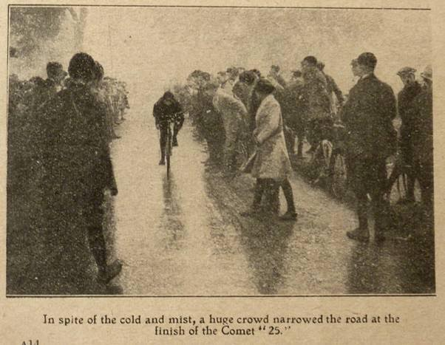
The Comet finish in 1924.
There were 300 entries, of which 150 rode*

THANK YOU
To all Timekeepers, Marshals and Stewards.
To Keith West, for his invaluable help with the computing.

I wish all riders a safe ride and a good time.
Michael

*Acknowledgements to Cycling and Fergus Muir, Tricycle Association.

